**Lab3**

**Configuring Apache Web server in Linux instance – for Beginners**

While logged in to AWS management console, Kindly click “EC2” service.

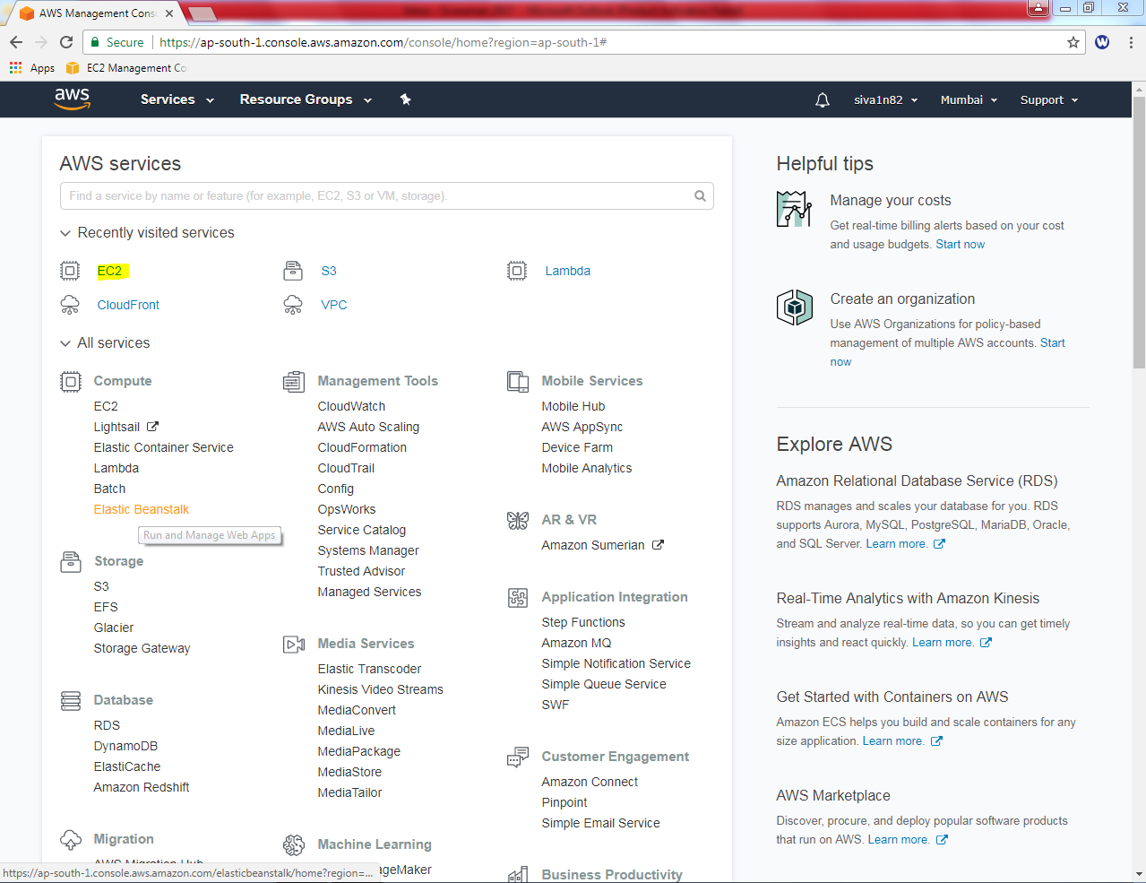

Click “Launch Instance”.

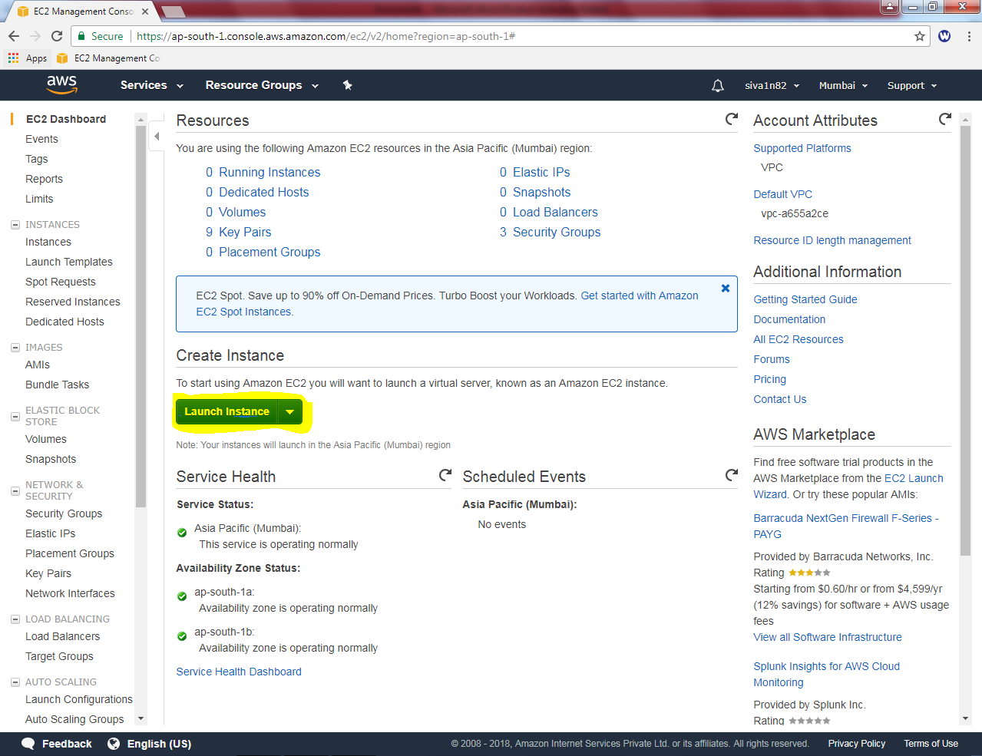

Select “Amazon Linux”.

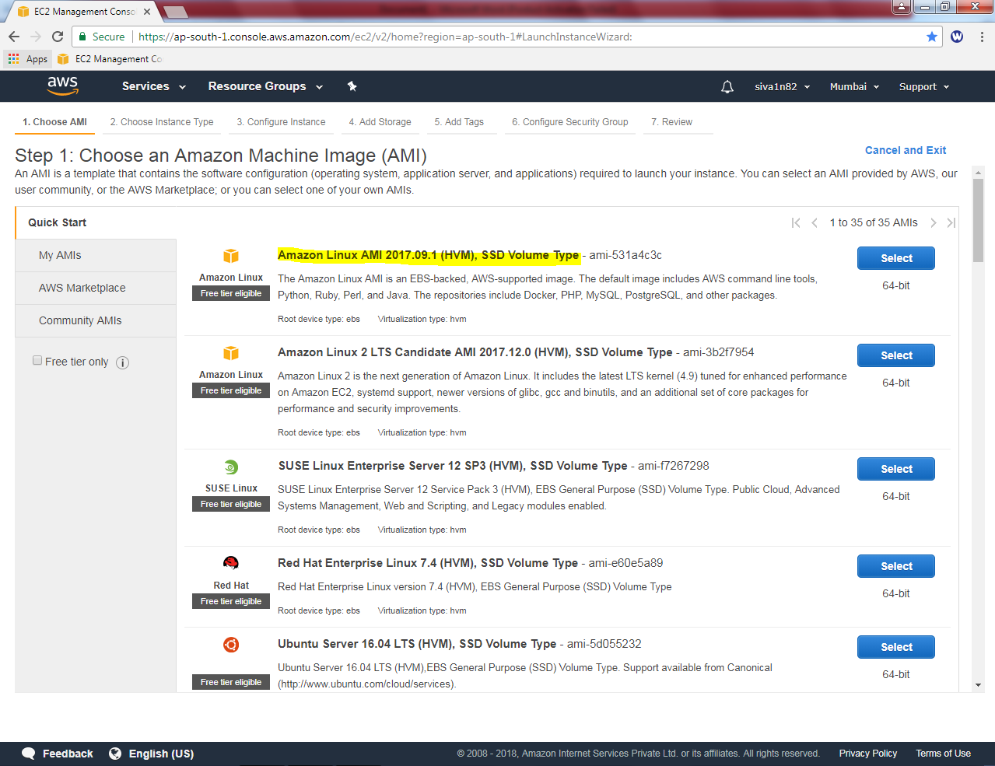

Ensure that “General Purpose – t2 micro” is selected.

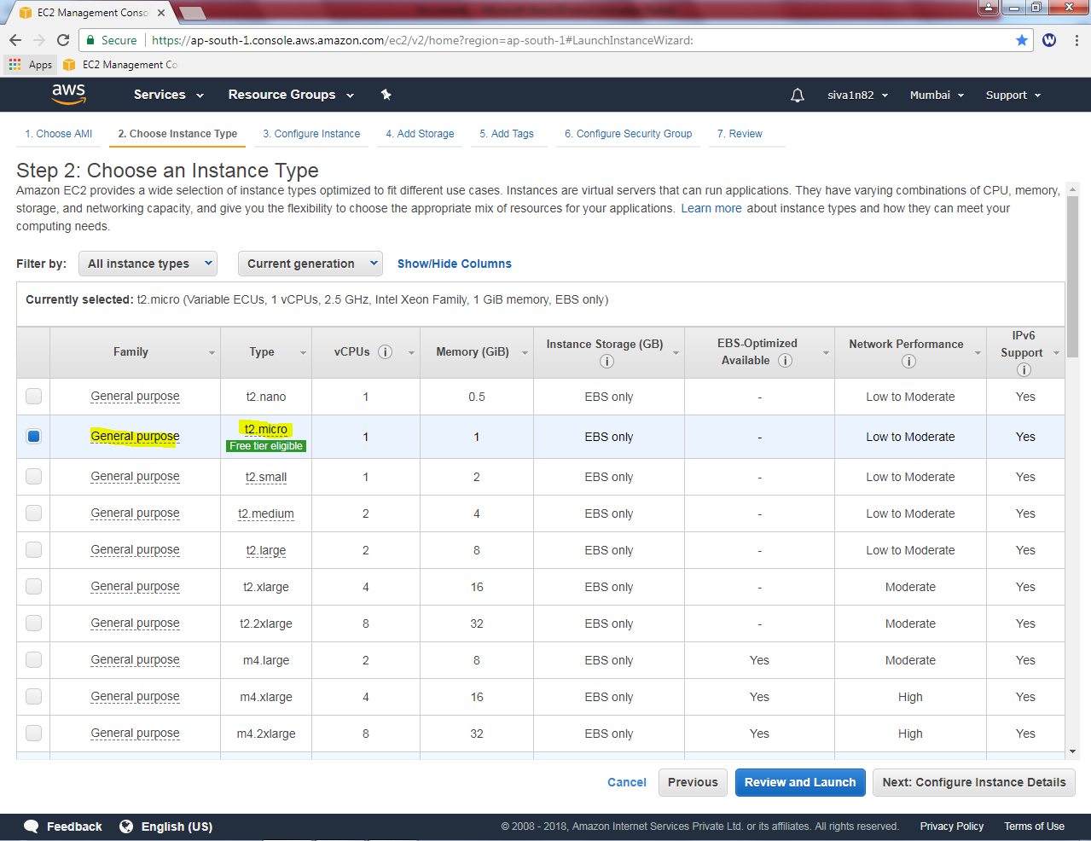

Click “Next”.

Leave default settings and click “Next”.

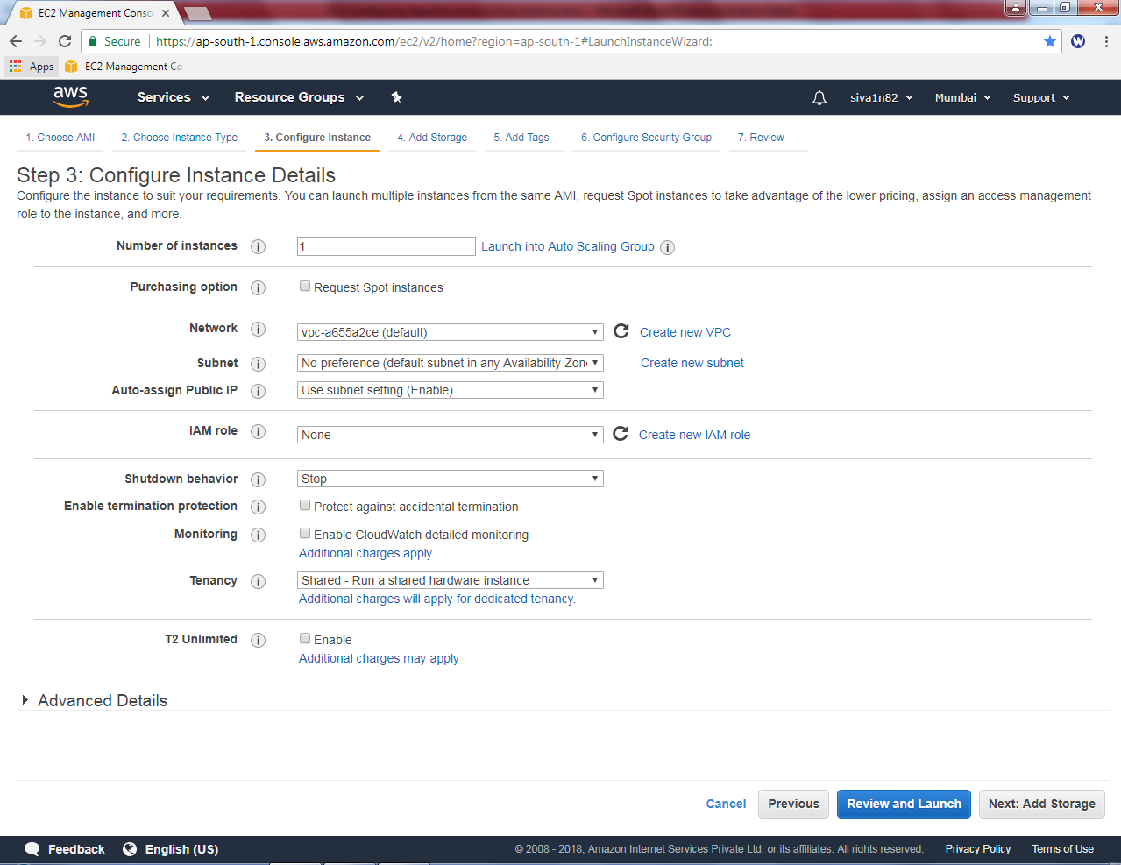

Leave default settings and click “Next”.

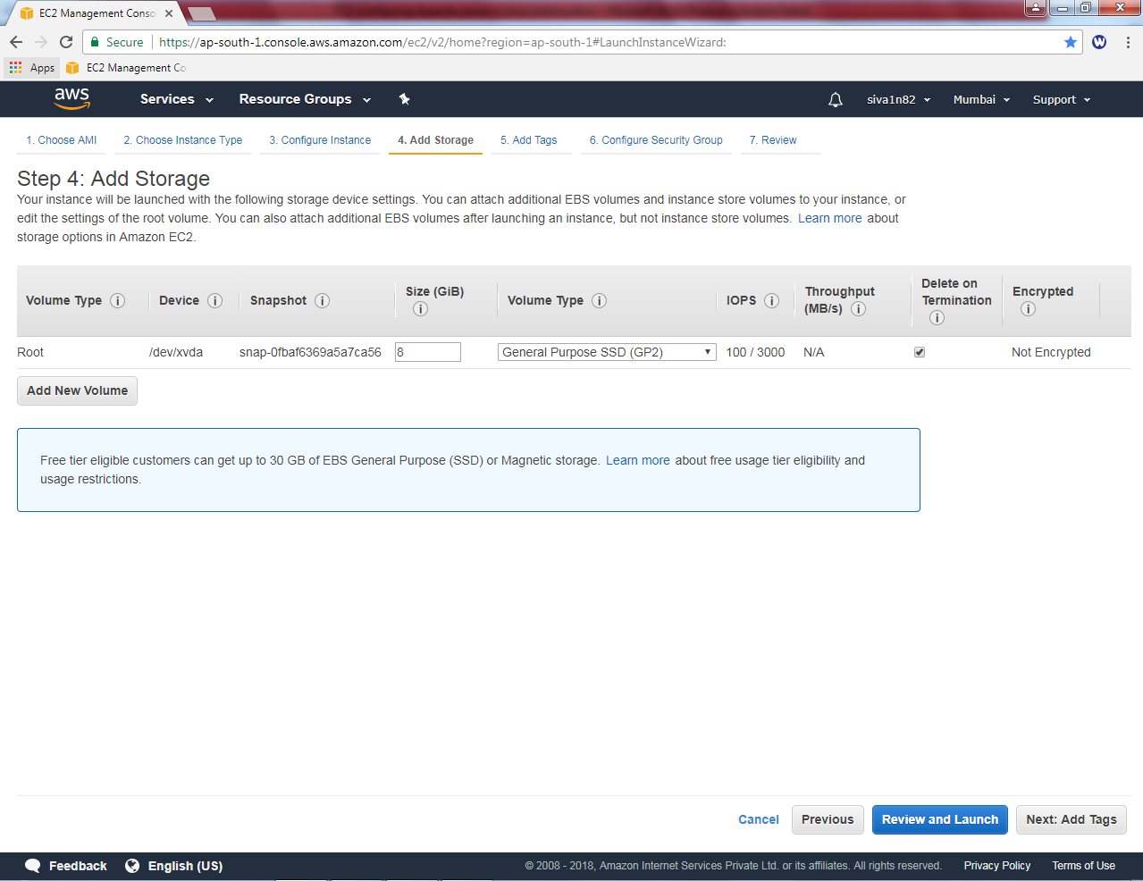

In Add tags, Key as “Name”and value as “Linux Instance”.

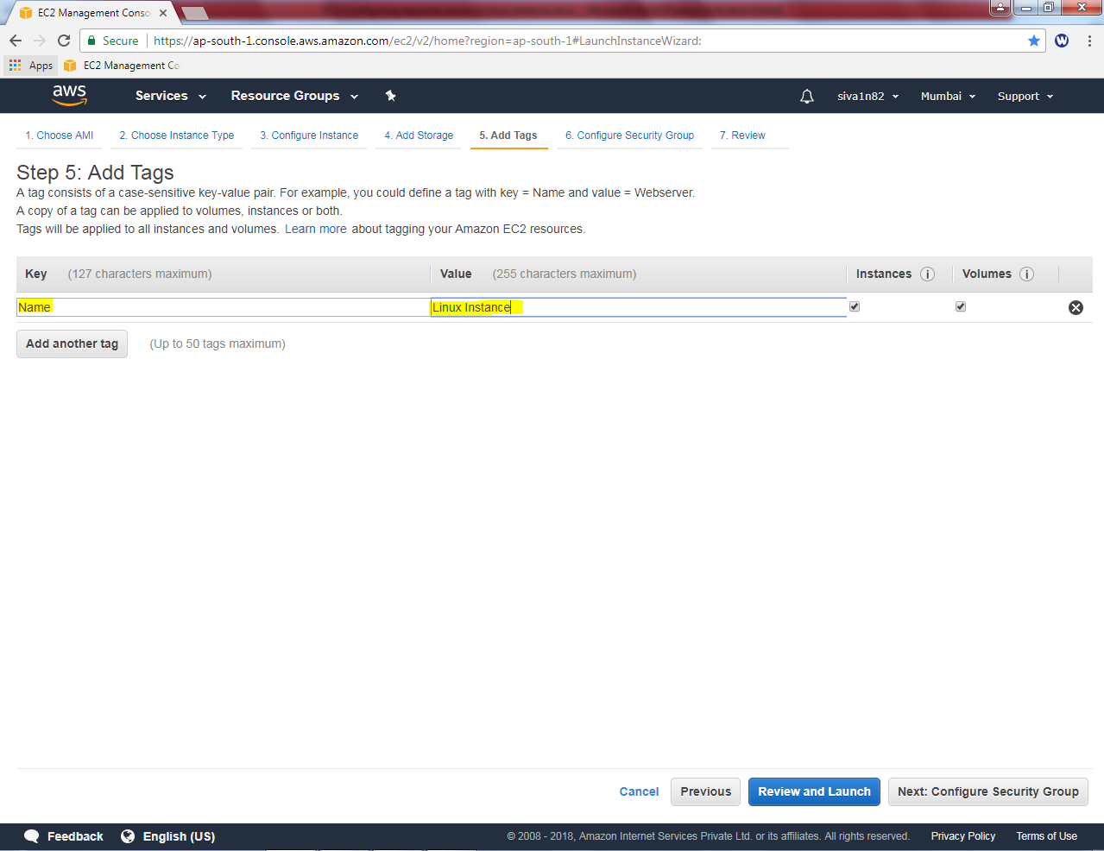

Click “Next”.

While configuring security group, create a new security group for Linux Instance.

Type security group name as Linux-Sec-Group

Description as Linux-Sec-Group

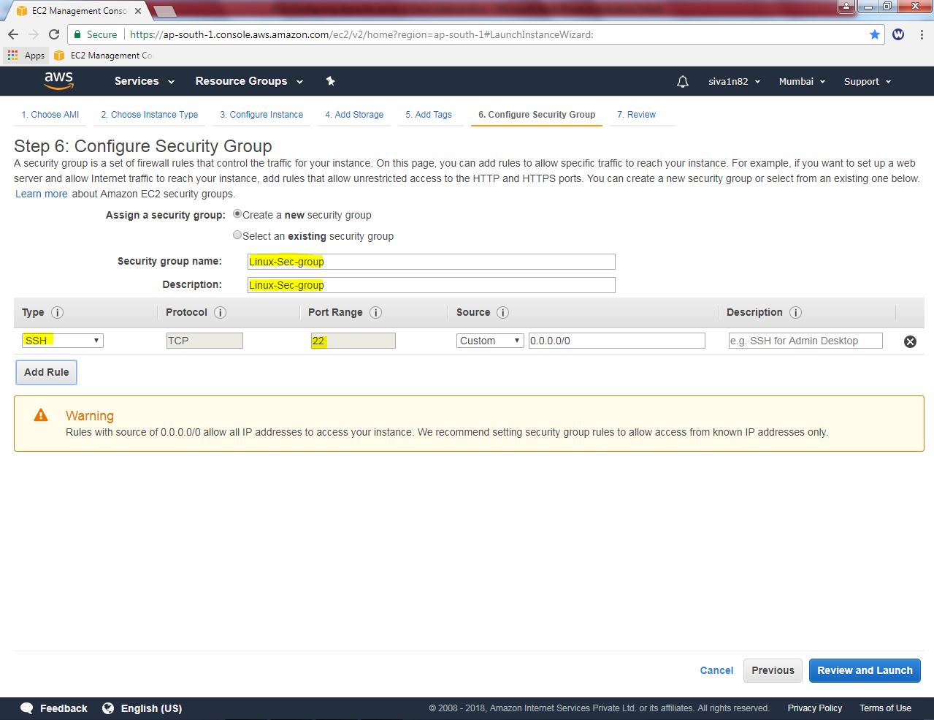

Click “Review and Launch”.

Leave default settings and click “Launch”.

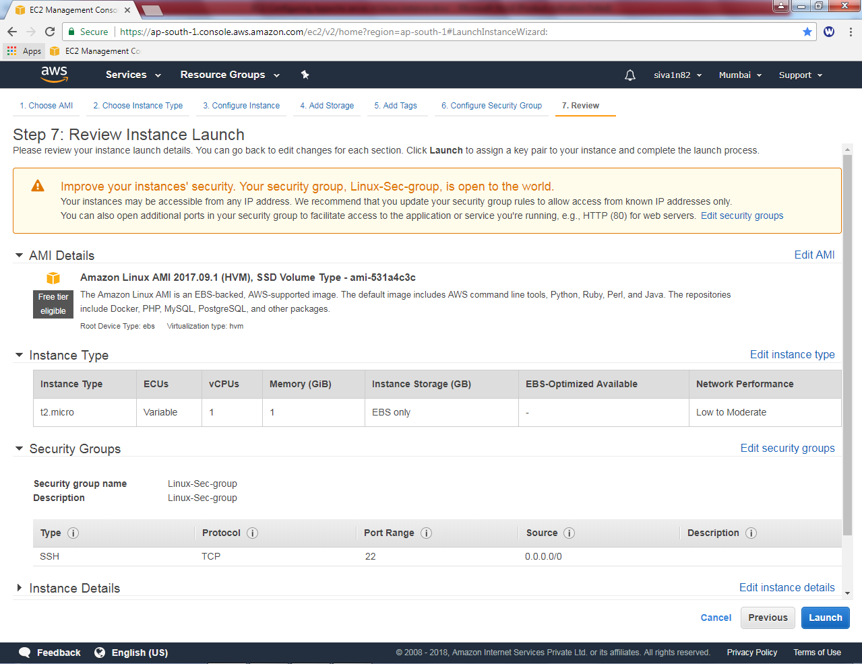

While click “launch” it ask to select an existing key pair or create a new key pair option.

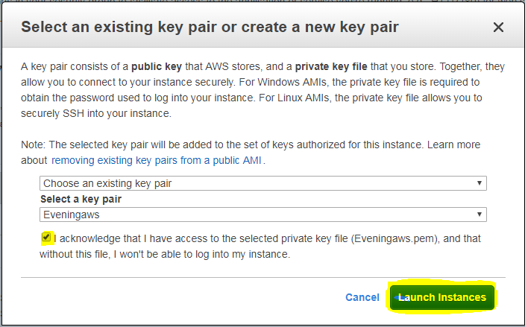

Select the choose an existing key pair if you have already downloaded *.pem file. Otherwise click create a new key pair. We have already key with us, hence I have selected choose an existing key pair option. And select the “Eveningaws” key from drop down box. Then click “I acknowledge”.

Click “launch instance”.

Now you have created an instance and launched successfully. Click the highlighted area or view instance to view the Linux instance.

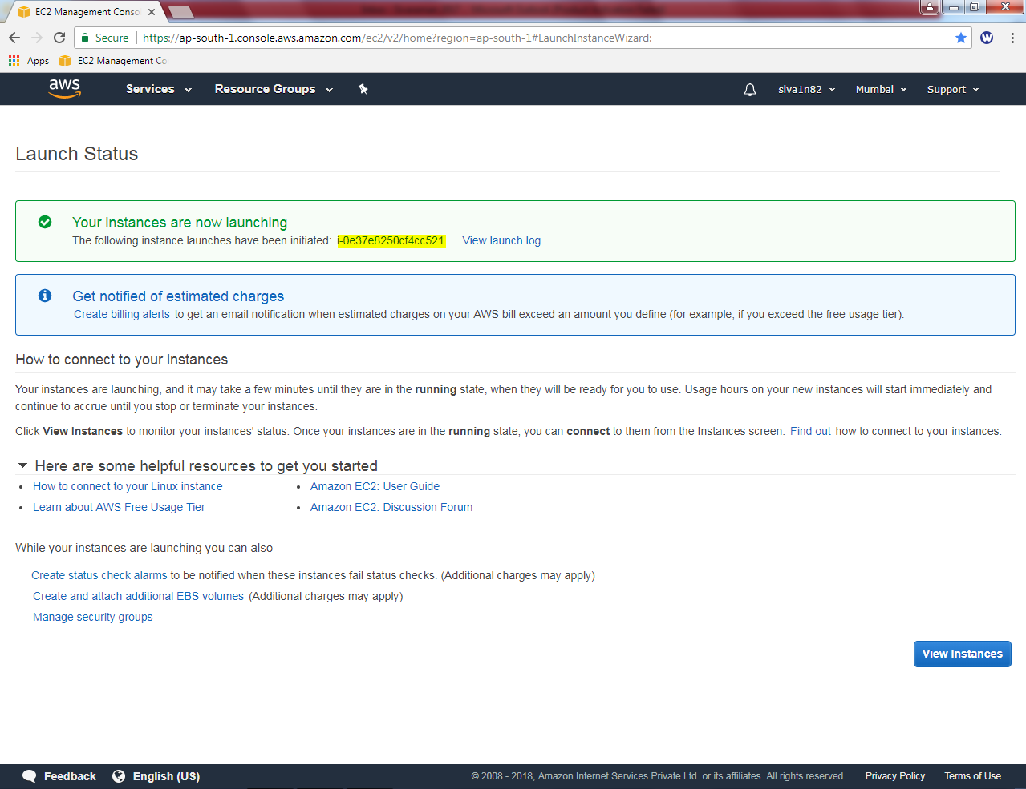

Please wait up to the status checks becomes 2/2 checks.

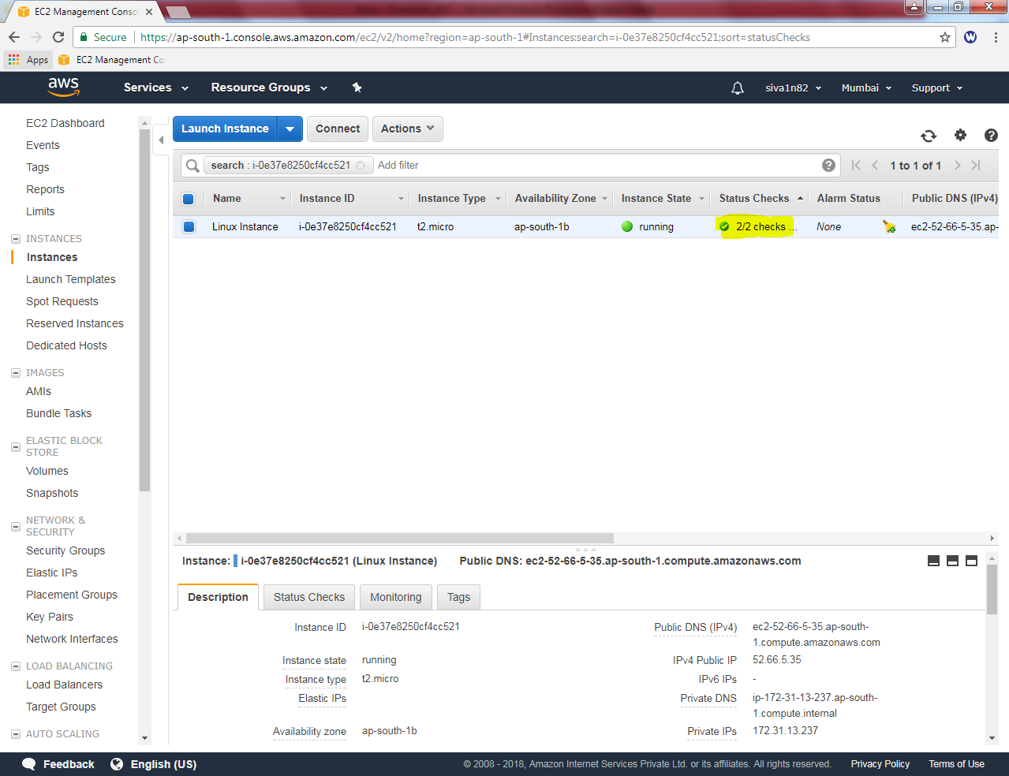

Install putty application in your machine

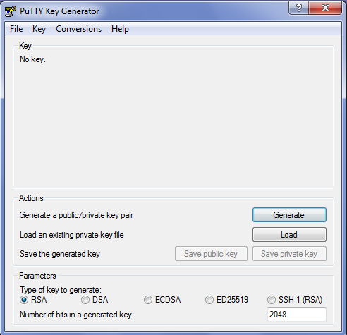

Click File 🡪 Load private key

Select the private key file and then click “Open”.



Getting notice that successfully imported the key.

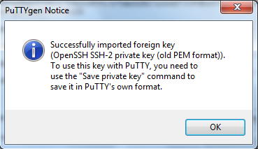

Click “Save Private Key”.

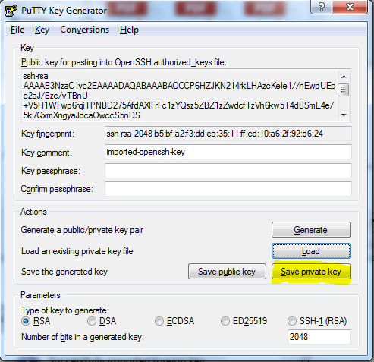

Click”Yes”to continue.

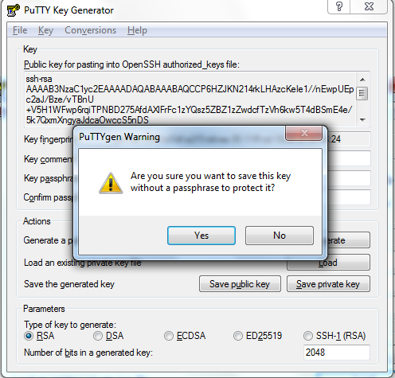

Save the file as “Eveningaws.ppk”



Click “save”.

In Putty, type the Public IP address of Linux.

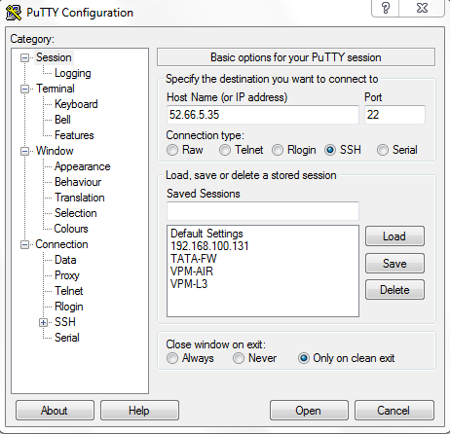

Click “SSH”

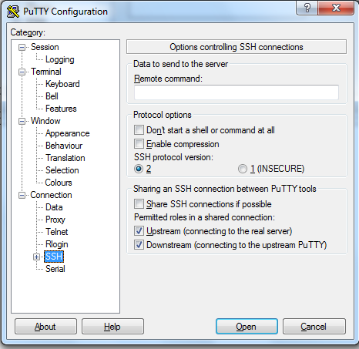

Expand “SSH” then click “Auth”.

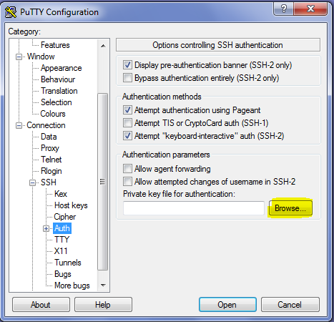

Then Browse and

locate the *.ppk file.



.

Click “Open”.

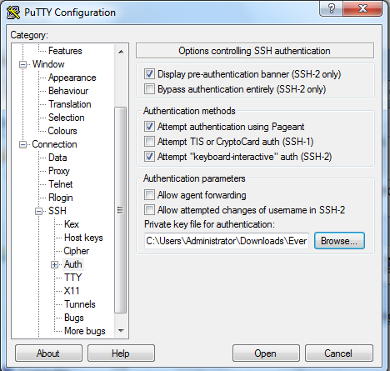

Click “Yes”.

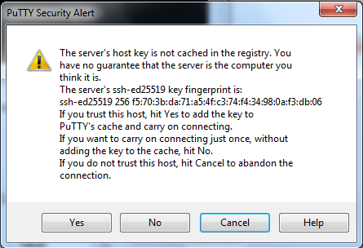

Type user as **ec2-user**

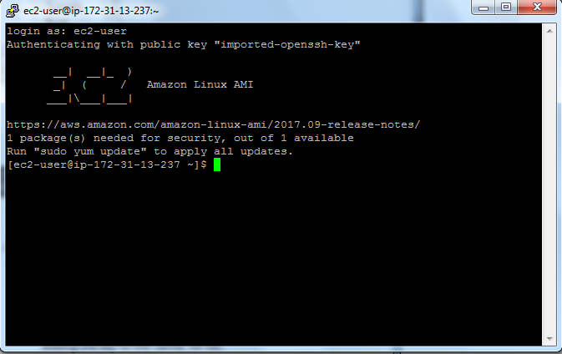

Type,

***Sudo –i***

Now it has been switched root privilege account.

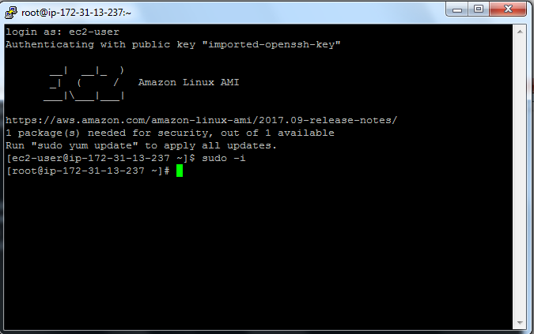

Type

***Yum install httpd***

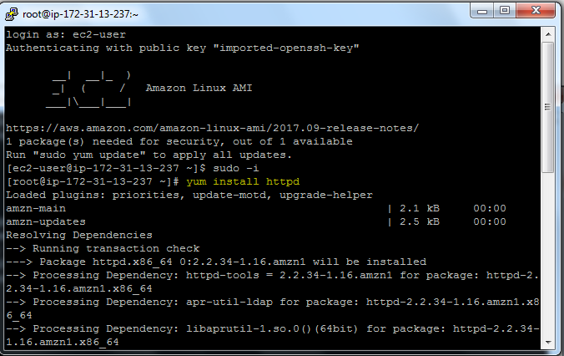

Type **“Y”**to install the packages.

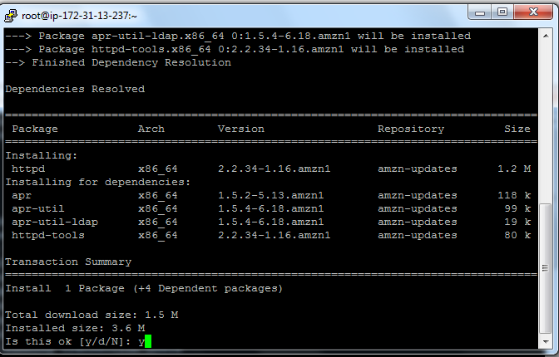

Now web server has been installed successfully.

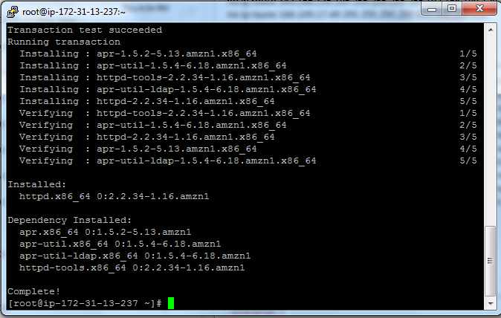

Now we need to start the service htttpd

Type command,

***Service httpd start***

***Chkconfig httpd on***

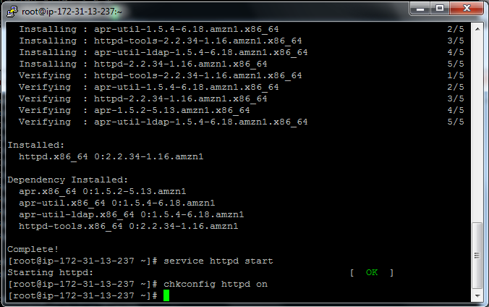

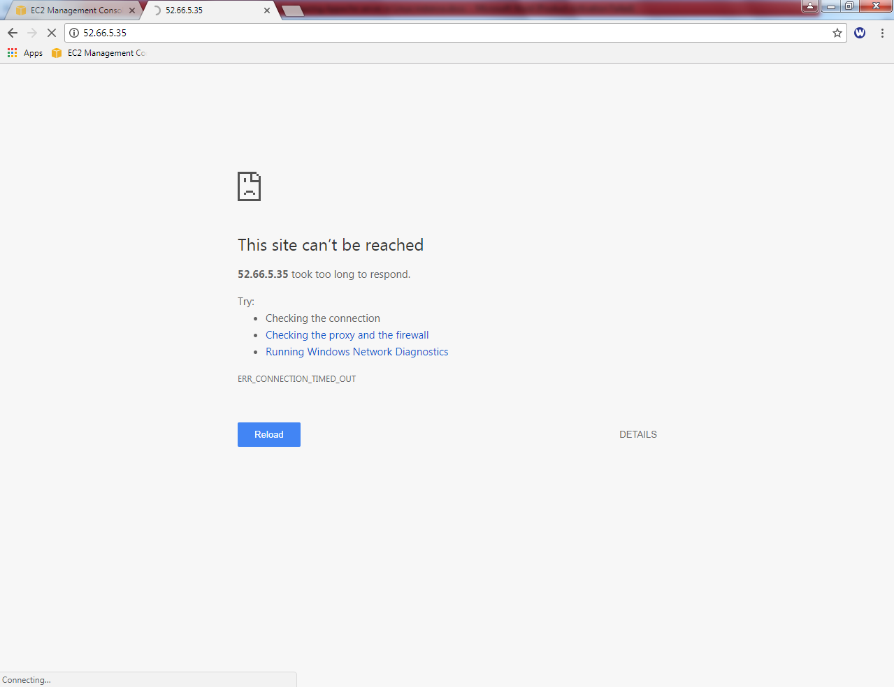

You would not be able to connect, what could be the reason?

In security group, we have permitted only SSH Port (22). Hence we are unable to connect port 80 from outside of the network. Now we need to allow port 80 (HTTP) in security group “Linux-Sec-Group”.

Go to security Group in EC2, select Linux-sec-group and then click “Inbound”tab.

Click “Edit”.

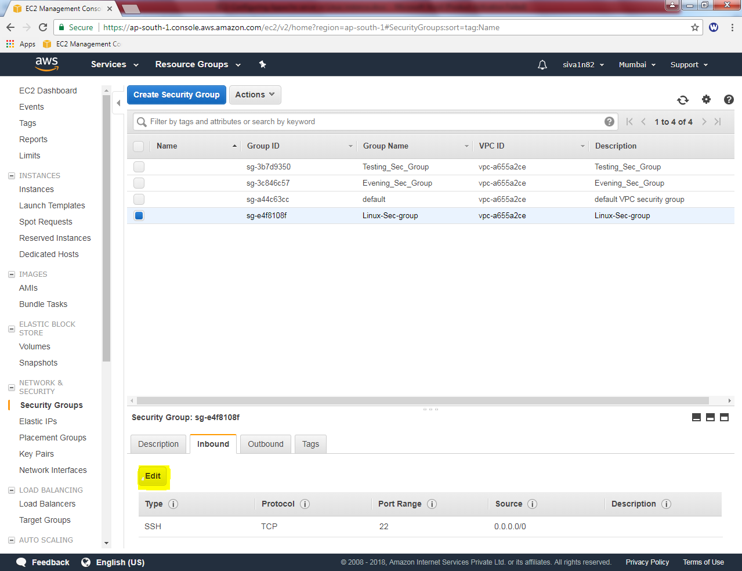

Click “Add rule” button

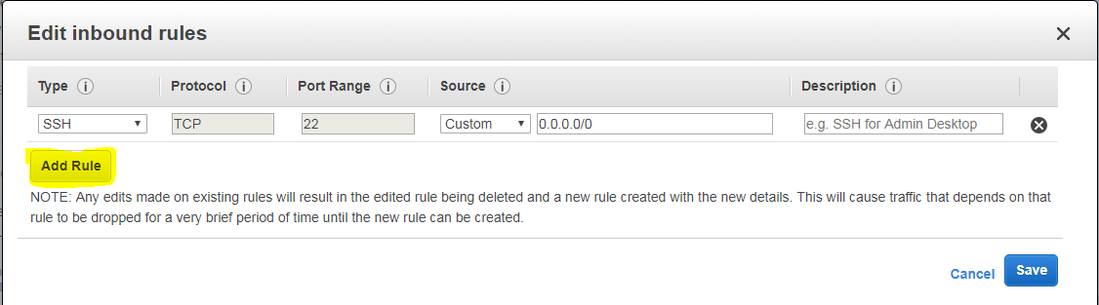

Select “HTTP” and custom source as 0.0.0.0/0, (for IPV4) and ::/0 (for IPV6).

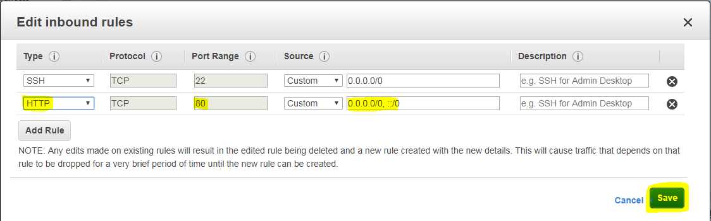

Click “Save”.

Now try to connect the Apache web server in your local machine.

http://52.66.5.35

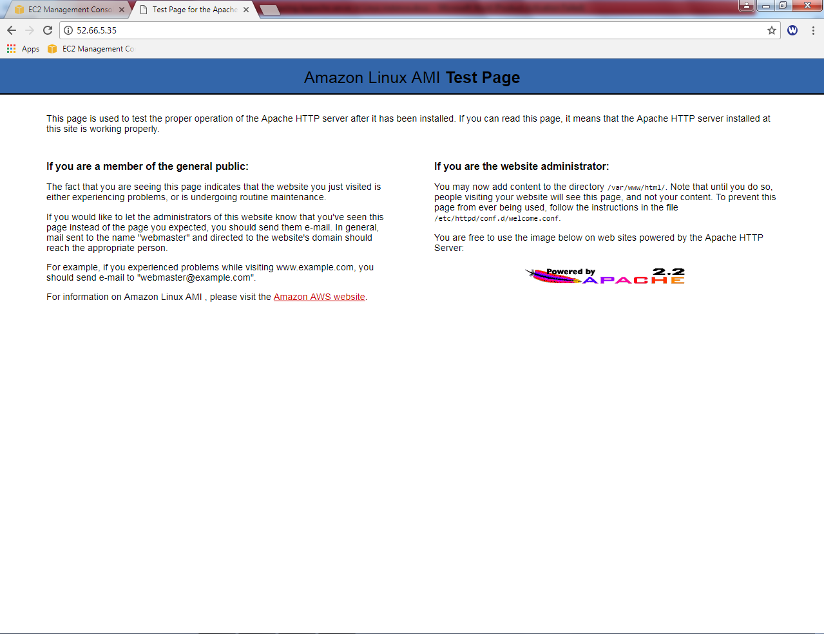

We have successfully got the web server page.